CC-215-L: Database Systems Lab
BS(IT/CS) Morning - Fall 2024
LAB – 02
The objective of this lab is to:
- Distinct
- Null values
- Like, Between, In
- Order by
- Char functions
COURSE & LAB INSTRUCTOR: Dr. Asif Sohail
LAB TIMING : 90 MINS
TOTAL MARKS : 45
Task 01: [15 marks]
- Display Employees information whose NAME length is 5. (Use of Length function is not allowed).
SELECT * FROM EMP WHERE ENAME LIKE '_____'
- Display the employees who earn “NO COMMISION” or have ‘COMMISION NULL’.
SELECT * FROM EMP WHERE COMM IS NULL OR COMM = 0
- Display the details of all employees whose salary is greater than 500 but less than 2500, and whose salary starts with the digit ‘1’.
SELECT * FROM EMP WHERE SAL BETWEEN 501 AND 2499 AND SAL LIKE '1%'
- Display the output in the following format:
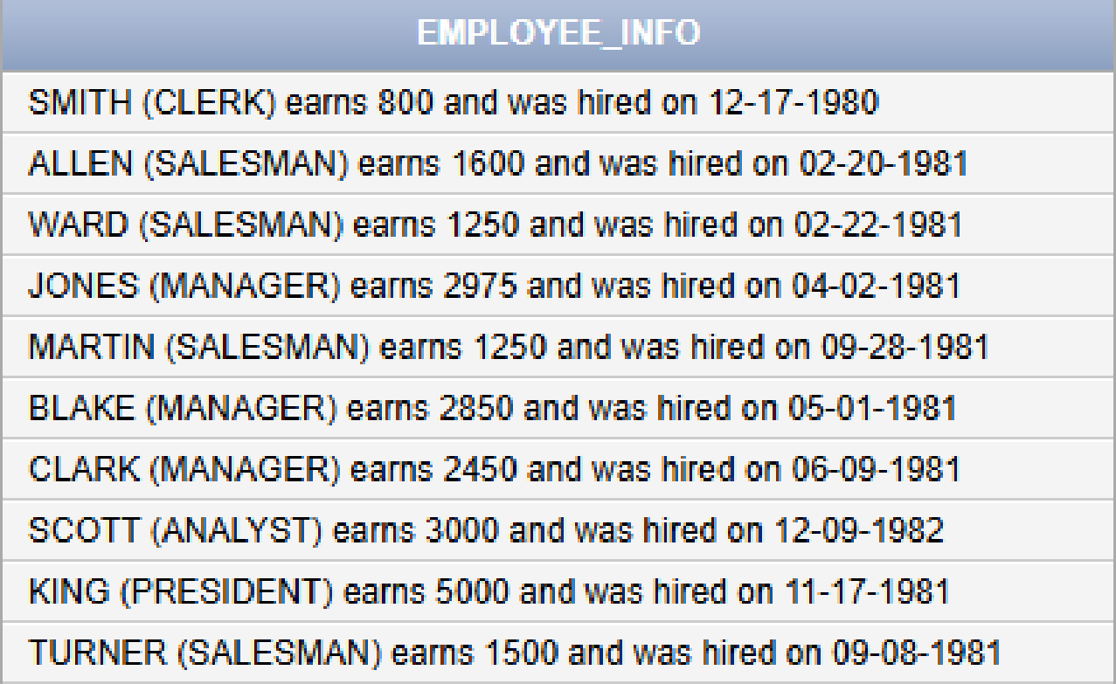
SELECT
ENAME || ' (' || JOB || ') ' ||
' EARNS ' || SAL ||
' AND WAS HIRED ON ' || SUBSTR(HIREDATE,1,2) || '-' || SUBSTR(HIREDATE,4,2) || '-' || SUBSTR(HIREDATE,7,4)
AS EMPLOYEE_INFO
FROM EMP;
- Display employee number, name, salary, and department number for employees earning 1500 or more, and order the results by salary in descending order.
SELECT empno, ename, sal, deptno FROM emp WHERE sal >= 1500 ORDER BY sal DESC;
- Display employee names that contain at least one 'S' and sort them by their SAL in the ascending order.
SELECT * FROM EMP WHERE ENAME LIKE '%S%' ORDER BY SAL
- Display the names, salary, and department number of employees whose 1st and 3rd letters of their name are the same
SELECT ENAME , SAL , DEPTNO FROM EMP WHERE SUBSTR(ENAME,1,1) = SUBSTR(ENAME,3,1)
- Write an SQL query to find the fifth occurrence index of the letter “E” in the string “EMPLOYEE BENEFITS"
SELECT INSTR('EMPLOYEE BENEFITS','E',1,5) FROM DUAL
- Retrieve the employees who have exactly one ‘A’ in their name. (Use of Character Functions is not allowed)
SELECT * FROM EMP WHERE ENAME LIKE '%A%' AND ENAME NOT LIKE '%A%A%'
- Display the employee number, name, job, salary, and department number for employees who work in department 20 or 30, whose job is either Salesman or Clerk.Order the results by department number in ascending order, and within each department by salary in descending order. (Use of OR operator is not allowed)
SELECT EMPNO, ENAME, JOB, SAL, DEPTNO FROM EMP WHERE DEPTNO IN (20, 30) AND JOB IN ('SALESMAN', 'CLERK') ORDER BY DEPTNO ASC, SAL DESC;
- Display the employee number, name, salary, commission, and total income (salary + commission) for employees whose salary is greater than 1200 and who receive a commission, and order the results by total income in descending order.
SELECT EMPNO, ENAME, SAL, COMM, (SAL + COMM) AS TOTAL_INCOME FROM EMP WHERE SAL > 1200 AND COMM > 0 ORDER BY (SAL + COMM) DESC;
- Display the employee number, name, modified name (where ‘A’ is replaced with ‘@’), job, and salary for employees whose job is Salesman. Order the results by employee name.
SELECT EMPNO, ENAME, REPLACE(ENAME, 'A', '@') AS MODIFIED_NAME, JOB, SAL FROM EMP WHERE JOB = 'SALESMAN' ORDER BY ENAME;
- Display the enames as the combination of first two letters and last two letters. Such as “Smith as Smth” etc.
SELECT ENAME, SUBSTR(ENAME,1,2) || SUBSTR(ENAME,-2,2) AS MODIFIED_ENAME FROM EMP;
- Display the employee name and the position of the letter ‘A’ in the name.
SELECT ENAME, INSTR(ENAME, 'A') AS POS FROM EMP;
- Display the employee details for the employees with the length of the name greater than .
SELECT * FROM EMP WHERE LENGTH(ENAME) > 5;

Task 02: [16 marks]
- Write a query to display student names that have only two words in the following format:
Example: Ali Sabir becomes A.S
Bonus Task:
As a bonus you can extend it to three word names, and output the result in the following format:
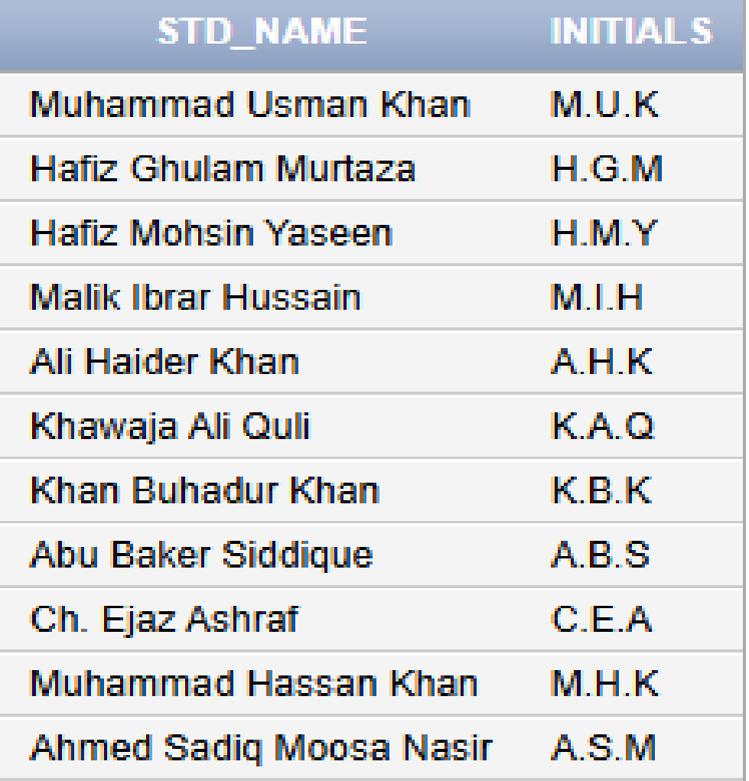
SELECT STD_NAME, STD_NAME, SUBSTR(STD_NAME, 1, 1) || '.' || SUBSTR(STD_NAME, INSTR(STD_NAME, ' ')+1, 1) FROM PUCIT WHERE LENGTH(STD_NAME) - LENGTH( REPLACE(STD_NAME,' ','')) + 1 = 2
Bonus Task:
SELECT STD_NAME, SUBSTR(STD_NAME, 1, 1) || '.' || SUBSTR(STD_NAME, INSTR(STD_NAME, ' ')+1, 1) || '.' || SUBSTR(STD_NAME, INSTR(STD_NAME, ' ', INSTR(STD_NAME, ' ')+1)+1, 1) AS INITIALS FROM PUCIT;

- Display employee names where all vowels are replaced with ‘*’. For example, 'SMITH’ becomes ‘SM*TH’.
SELECT ENAME, TRANSLATE(ENAME, 'AEIOU','*****' ) AS MODIFIED_ENAME FROM EMP
- Display the employee number, name, job, and department number for employees whose name contains the letter ‘A’, whose name length is greater than 4, and who do not have the letter ‘S’ in their name. Order the results by name length in descending order, and then alphabetically
SELECT ENAME,JOB ,DEPTNO FROM EMP WHERE ENAME LIKE '%A%' AND LENGTH(ENAME) > 4 AND ENAME NOT LIKE '%S%' ORDER BY LENGTH(ENAME) DESC, ENAME
- Display the employee name, a coded version of the name (where vowels A, E, I, O, U are replaced with 1, 2, 3, 4, 5 respectively, and the letter ‘S’ is replaced with ‘$’), job, and department number. Retrieve only those employees whose names have more than 5 characters. Order the results by the coded name
SELECT ENAME, REPLACE(TRANSLATE(ENAME, 'AEIOU', '12345'), 'S', '$') AS CODED_NAME, JOB, DEPTNO FROM EMP WHERE LENGTH(ENAME) > 5 ORDER BY CODED_NAME;
- Display the employees whose name starts with the letter ‘S’. (Use of Like operator is not allowed)
SELECT * FROM EMP WHERE ENAME >='S' AND ENAME < 'T'
- Display the grade, lower salary, and higher salary for grades between 2 and 4, ordered by grade in descending order.
SELECT * FROM SALGRADE WHERE GRADE BETWEEN 2 AND 4 ORDER BY GRADE DESC
- Generate employee codes in the format EMP-EMPNO for employees who have no commission, ordered by employee number.
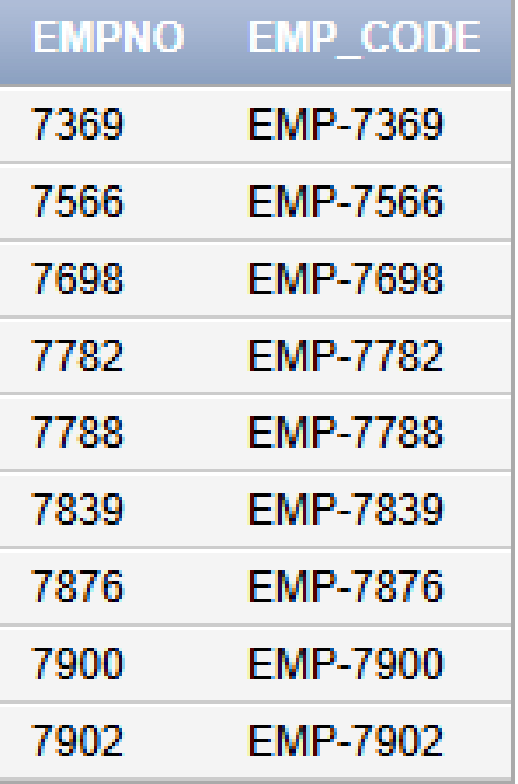
SELECT EMPNO, CONCAT('EMP-', EMPNO) AS EMP_CODE FROM EMP WHERE COMM IS NULL ORDER BY EMPNO;
- Generate a “custom employee badge” in the format YY-DDD-LLL, where:
- YY - last 2 digits of the year in HIREDATE
- DDD - DEPTNO padded to 3 digits with zeros
- LLL - last 2 letters of ENAME in uppercase
Restrict the output to employees whose salary is greater than 2000 or who are in DEPTNO 10.
SELECT EMPNO, ENAME, SUBSTR(TO_CHAR(HIREDATE, 'YY'), -2) || '-' || LPAD(DEPTNO, 3, '0') || '-' || SUBSTR(ENAME, -2) AS EMP_BADGE FROM EMP WHERE SAL > 2000 OR DEPTNO = 10;
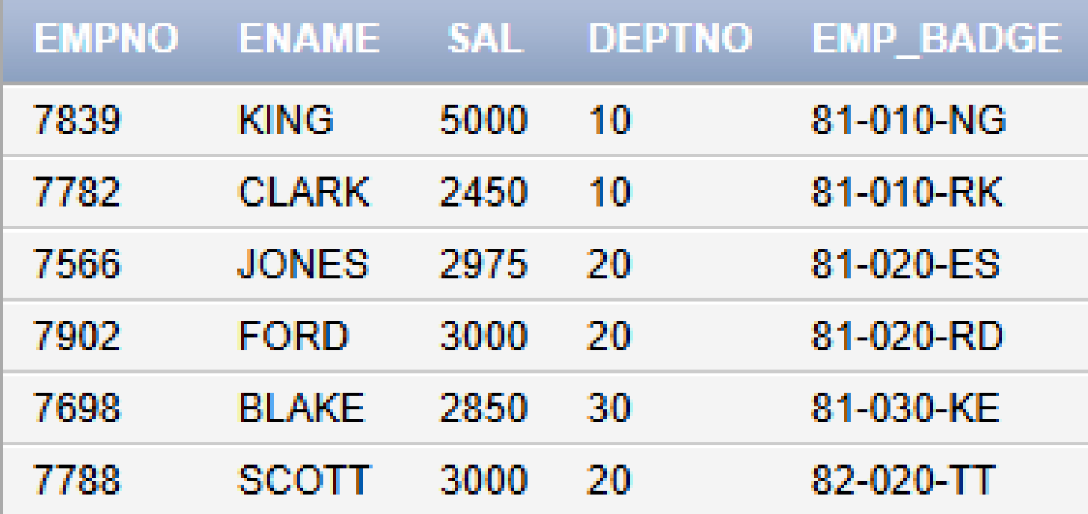
- Find the total words in the name of each student in PUCIT table. For example, the name “Habib Ghulam Bheek” has three words.
SELECT STD_NAME, (LENGTH(STD_NAME) - LENGTH(REPLACE(STD_NAME, ' ', ''))) + 1 AS WORD_COUNT FROM PUCIT;

- List all employees who:
- Work in departments 20 or 30
- Have a job either ‘SALESMAN’ or ‘MANAGER’
- Were hired in the first half of any year (February to June)
- Have a salary greater than 1000 or commission is NOT NULL
And whose names end with the letter ‘S’

Display: EMPNO, ENAME, JOB, DEPTNO, SAL, COMM, HIREDATE.
SELECT EMPNO, ENAME, JOB, DEPTNO, SAL, COMM, HIREDATE
FROM EMP
WHERE DEPTNO IN (20, 30)
AND JOB IN ('SALESMAN','MANAGER')
AND (SAL > 1000 OR COMM IS NOT NULL)
AND ENAME LIKE '%S'
AND SUBSTR(HIREDATE,1,2) >= '01' AND SUBSTR(HIREDATE,1,2) <= '07';
Task 03: [9 marks]
- Display employee names by inserting a hyphen before the last character. Example: ALLEN becomes ALLE-N
SELECT ENAME, SUBSTR(ENAME, 1, LENGTH(ENAME)-1) || '-' || SUBSTR(ENAME, -1) AS MODIFIED_ENAME FROM EMP;
- Display the names of employees after removing the last two letters from each name. Additionally, replace each vowel in the remaining part of the name with a corresponding digit. For example ‘A’ is replaced by ‘1’,’E’ is replaced by 2,’I’ is replaced by 3,’O’ is replaced by 4,’U’ is replaced by 5.
SELECT ENAME, JOB,TRANSLATE(SUBSTR(ENAME, 1,LENGTH(ENAME) - 2),'AEIOU', '12345') AS TRANSLATED_NAME FROM EMP
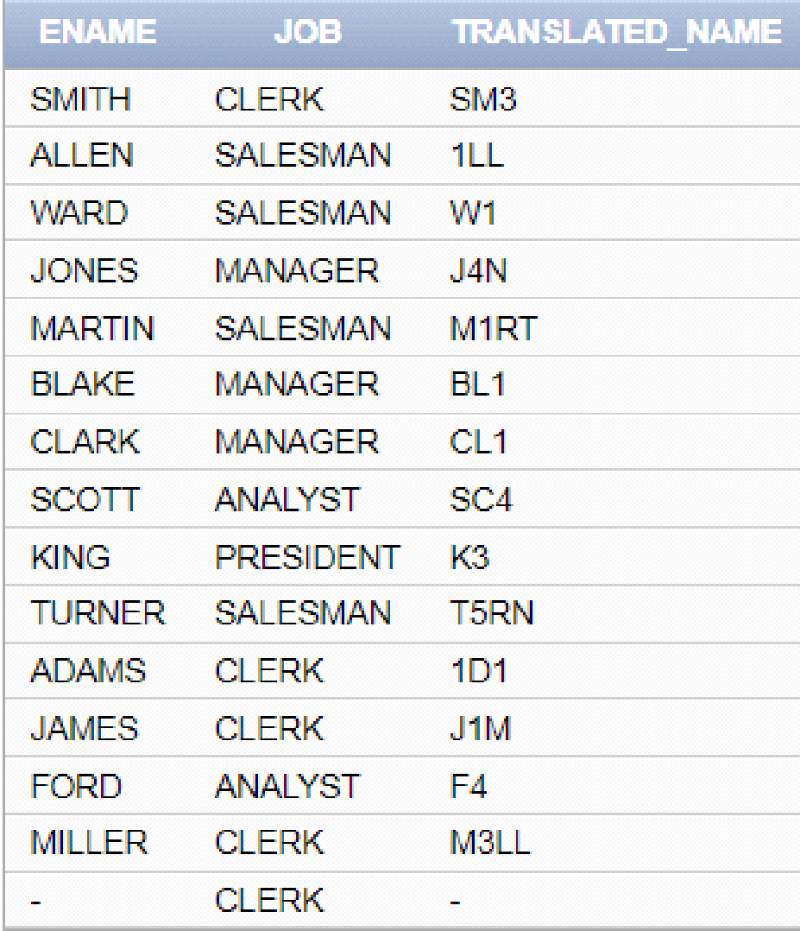
- .Select all the employees from emp table and display a column such that the first 2 digits of empno are concatenated with the last three characters of the name. Also add number of dollar Sign ‘$’ to the left and right side, equal to the length of the name.
SELECT RPAD(LPAD(CONCAT(CONCAT(SUBSTR(EMPNO,1,2),'-') , SUBSTR(ENAME,-3)), LENGTH(ENAME) + LENGTH(CONCAT(CONCAT(SUBSTR(EMPNO,1,2),'-') , SUBSTR(ENAME,-3))),'$'),LENGTH(LPAD(CONCAT(CONCAT(SUBSTR(EMPNO,1,2),'-') , SUBSTR(ENAME,-3)), LENGTH(ENAME) + LENGTH(CONCAT(CONCAT(SUBSTR(EMPNO,1,2),'-') , SUBSTR(ENAME,-3))),'$')) + LENGTH(ENAME), '$')
AS NEW_COLUMN FROM EMP
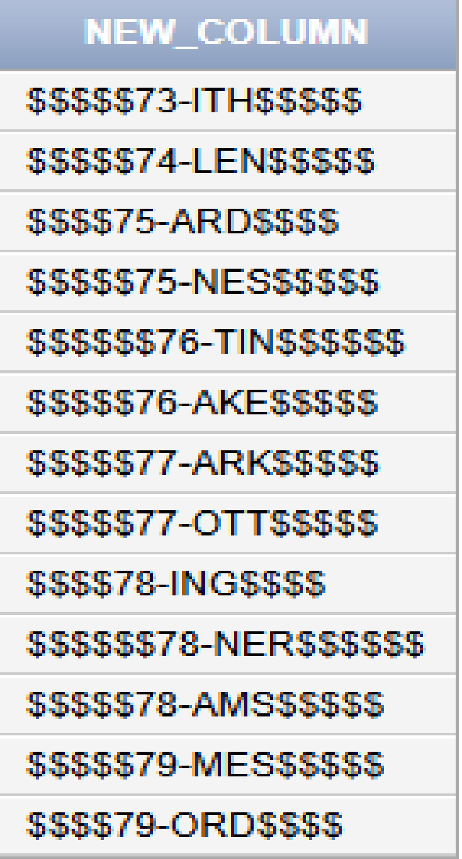
Task 04: [5 marks]
VIVA VOCE

